EXPERIMENT-5
5) Write a Python function to analyze the histogram of the given input image based on color
- CODE
- import cv2
- import matplotlib.pyplot as plt
- img = cv2.imread("photo.jpg")
- for i, c in enumerate(('b', 'g', 'r')):
- hist = cv2.calcHist([img], [i], None, [256], [0, 256])
- plt.plot(hist, color=c)
- plt.title("Color Histogram")
- plt.xlabel("Pixel Intensity")
- plt.ylabel("Number of Pixels")
- plt.savefig("color_histogram.png")
- plt.show()
- print("Histogram analyzed successfully")

b) INPUT
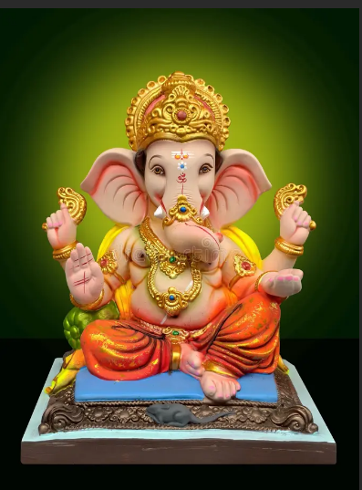
c) OUTPUT
